General Inversion for Phase Technique (GIPhT)  
Users’ Manual

Kurt L. Feigl, Peter Sobol, Lee Powell, Clifford Thurber  
   
University of Wisconsin-Madison

|  |  |
| --- | --- |
| FTfig3 | *Abstract*— Interferometric analysis of synthetic aperture radar images (InSAR) measures the phase shifts between two images acquired at two distinct times. These ambiguous 'wrapped' phase values range from -1/2 to +1/2 cycles. The standard approach interprets the phase values in terms of the change in distance between the ground and the radar instrument by resolving the integer ambiguities in a process known as 'unwrapping'. To avoid unwrapping, GIPhT models the wrapped phase data directly. GIPhT defines a cost function in terms of wrapped phase to measure the misfit between the observed and modelled values of phase. By minimizing the cost function with a simulated annealing algorithm, GIPhT estimates parameters in a non-linear model. Since the wrapped phase residuals are compatible with a von Mises distribution, several parametric statistical tests can be used to evaluate the fit of the model to the data. GIPhT can handle noisy, wrapped phase data. The software documented here can be applied to a set of interferograms acquired of the same area under a single imaging geometry. This manual describes several example data sets, including subsidence, an earthquake, and a volcano. These examples illustrate simple modeling of the deformation associated with these phenomena. |

Last updated .

© 2009-2103 Kurt L. Feigl, Peter Sobol, Lee Powell, Clifford Thurber.  All rights reserved.

U.S. Patent No. 7,446,705.

Use of this computer program [GIPhT] is governed by a license agreement between You and the Wisconsin Alumni Research Foundation (the “Agreement”).  Unauthorized use, reproduction, or distribution of this program or any portion of it may result in severe civil and criminal penalties, and will be prosecuted to the maximum extent possible under the law.  By using this program, you agree to be bound by the terms of the Agreement.

Kurt L. Feigl is a Professor with the University of Wisconsin-Madison, 1215 West Dayton Street, Madison, WI 53706 USA.   
(phone: +1 608-262-8960; fax +1 262-0693; e-mail: feigl@wisc.edu).

Peter Sobol is a Senior Instrumentation Innovator with the University of Wisconsin-Madison.

Lee Powell retired as Senior Instrumentation Innovator with the University of Wisconsin-Madison in 2010.

Clifford H. Thurber is a Professor with the University of Wisconsin-Madison.

# Table of Contents

Table of Contents 2

I. INTRODUCTION 4

II. Preparation 4

A. Installing Matlab 4

B. Downloading GIPhT 4

C. Installing GIPhT 4

D. Starting GIPHT 4

III. Fawnskin Earthquake 5

A. Description 5

B. Starting GIPHT 5

IV. Input Files 5

A. Input file **gipht.in** 5

B. Digital Elevation Model (DEM) — input descriptor file 13

C. Digital Elevation Model (DEM) — input binary file 15

D. Input file **file_names.dat** 15

E. Input file interferograms.lst (optional) 15

F. Input phase files 16

G. Initial estimates of model parameters 16

H. coh.byt 17

V. Output Files 18

1) Log file 18

2) x.log 18

3) Output parameters file 19

4) Phase values plotted on maps with coordinates 22

5) Phase values in binary RAW format 22

6) Phase files 22

7) ikeep.mat and jkeep.mat 22

8) matlab.mat 22

9) unitv.mat 22

10) unitv2.mat 23

11) x.pdf 23

VI. Subsidence Example (demo4) 23

A. Description 23

VII. Applying GIPhT to other Data Sets 25

A. Make and populate a directory 25

1) reduce the number of pairs 25

VIII. Troubleshooting 25

A. Calculation takes too long 25

1) Reduce the number of pairs 25

2) Reduce the number of pixels 25

3) Avoid quadtree sampling of the data set 25

B. Final estimate does not look like the data 25

1) Improve the initial estimate 25

2) Check the sign of the phase values 26

3) Shrink the sub-region 26

C. The residual interferogram shows twice as many fringes as either the observed or the modeled interferogram. 26

D. The model is all green. 26

E. There are crenulated fringes in some of the interferograms. 26

F. I do not have a DEM. 26

G. The format of the parameters.in file is wrong 26

H. The program crashes 27

1) Remain calm 27

2) Look for hints in the output 27

3) Send the output to Madison 27

IX. Conclusion 27

References 28

# INTRODUCTION

Synthetic aperture radar (SAR) is an active remote sensing technique used for measuring geophysical activity on the Earth’s surface. It records microwaves transmitted by a sensor (usually aboard a satellite) and reflected by features on the Earth’s surface (usually on land). The reflected signal contains information in the form of amplitude and phase data, and requires sophisticated post-processing. A technique known as interferometric SAR (InSAR) measures the difference in phase between two images of the same area, which can be used to measure motion and deformation of the ground. In most applications, the interferogram must be “unwrapped” before it can be interpreted. The unwrapped interferogram may be used to monitor geophysical changes on the Earth’s surface associated with earthquakes, volcanoes, landslides or glaciers, or with the withdrawal of oil, gas, water or minerals by extractive industries. Unwrapping requires considerable computational power and time, and may lead to significant mistakes in the unwrapped interferogram and thus in its intepretation. These issues can become especially problematic in cases where the data are noisy or the fringes are discontinuous, for example in a fault zone where an earthquake has ruptured the ground surface. To avoid these issues, GIPhT is designed to interpret an interferogram without the need for unwrapping, as described by Feigl and Thurber [*Feigl and Thurber*, 2009]. To do so, GIPhT estimates parameters in a quantitative model directly from the wrapped phase data. The goal is to produce a modeled interferogram that resembles the observed interferogram. To reach this goal, GIPhT minimizes the angular deviation between the observed and measured values of the interferometric phase.

# Preparation

## Installing Matlab

See Matlab <http://www.mathworks.com/products/matlab> .

## Downloading GIPhT

After signing the license agreement, download from UW MyWebspace using the URL beginning with: https://mywebspace.wisc.edu

## Installing GIPhT

Uncompress the downloaded files.

## Starting GIPHT

The directory called **demoF2** contains an example from the Fawnskin earthquake in California, as described in more detail below.

Inside Matlab, change the working directory to the folder called **demoF2**.

Using the Matlab editor, open the **giphtpath.m** file. Modify the GIPHT_HOME environment variable to point to the directory where you installed src and extern directories.

On the Matlab command line, type:

gipht

The program should begin by writing textual output to the terminal window. Figures, beginning with a copyright notice, should appear in separate windows. If not, the most common error has to do with the path variable described above. The demonstration should take about 3 to 5 minutes to run to completion. At the end of the run, all the figures should close. The figures are preserved as output files in various formats, as discussed below.

# Fawnskin Earthquake

## Description

The directory called **demoF2** contains files for the Fawnskin earthquake. It is described in more detail in two peer-reviewed publications [*Feigl et al.*, 1995; *Feigl and Thurber*, 2009]. These two papers are available in the directory named **gipht/doc** in the PDF files named:

**FeiglEtAl1995GRL94GL03212.pdf**

**feiglThurber2009GJIpreprint.pdf**

## Starting GIPHT

Inside Matlab, change the working directory to the folder called **demoF2**.

Using the Matlab editor, open the **giphtpath.m** file. Modify the **GIPHT_HOME** environment variable to point to the directory where you installed src and extern directories.

On the Matlab command line, type:

gipht

The program should begin by writing textual output to the terminal window. Figures, beginning with copyright notice, should appear in separate windows. If not, the most common error has to do with the path variable described above. The demonstration should take about 3 to 5 minutes to run to completion. At the end of the run, all the figures should close. The figures are preserved as output files in various formats, as discussed below.

# Input Files

## Input file **gipht.in**

The file named **gipht.in** controls GIPhT. Each line contains a keyword followed by a numerical value. The numerical value controls how GIPhT operates. Following the numerical value, a percent (“%”) sign indicates that the remainder of the line is a comment.

#### Geographic sub-region

GIPhT operates on a rectangular subset of the interferograms. The sub-region is a subset of the “extract” region specified in the file called **dem_descriptor.dat,** as sketched in Figure 6. To define that sub-region, we must specify six numbers, including two horizontal coordinates, two pixel dimensions, and two dimensions of the sub-region. The coordinates may be specified in either of two ways. One possibility specifies the center of the sub-region in terms of geographic coordinates (latitude and longitude in decimal degrees):

% % COORDINATES: These values should be specified in the same system as the DEM,

% % as described in the dem_descriptor.dat file above

xcenter = -116.91 % Geographic Longitude in decimal degrees (positive East)

ycenter = 34.36 % Geographic Latitude in decimal degrees (positive North)

Alternatively, one may specify the center of the sub-region in terms of cartographic coordinates (easting and northing in meters), as calculated by a map projection, such as Universal Transverse Mercator (UTM) or Lambert:

% USE THESE VALUES FOR SMALL 121x81 SUB-REGION AROUND FAWNSKIN

xcenter = 506875 % Correct UTM easting in meters

ycenter = 3800986 % Correct UTM northing in meters

In either case, one must also specify the size of the sub-region in terms of its half-width (east-to-west dimension) and half-height (north-to-south dimension). The dimensions are defined in terms of the number of pixels.

% DIMENSIONS %

halfwidth = 60 % half the east-west width of the sampled region in pixels

halfheight = 40 % half the north-south height of the sampled region in pixels

The dimensions of an individual pixel are specified as step sizes in the file indicated by the demdescfile keyword. In this case, the file name is **dem_descriptor.dat.**

% File describing Digital Elevation Model (contains metadata)

demdescfile = dem_descriptor.dat

#### Specifying the filenames for the observed phase data

The file named **gipht.in** also includes the keyword **ilist** that points to a list of file names. In turn, each file named in the list contains observed phase values in a binary format.

% ilist = interferograms.lst % list of interferograms

#### Selecting the data

The file named **gipht.in** also includes the keyword **pselect** that controls how GIPhT selects the pixels for inversion from the rectangular sub-region. If keyword **pselect == 1**, then GIPhT selects the pixels randomly, as described by Feigl and Thurber [*Feigl and Thurber*, 2009]. If keyword **pselect == 2**, then GIPhT re-uses the same pixels as in the previous run and stored in the binary files **ikeep.mat** and **jkeep.mat.** For examples, see **demo2**, **demo4**, and **demoF2**. If keyword **pselect == 5**, then GIPhT selects the pixels using “quad-tree resampling”, as described by Ali and Feigl [*Ali and Feigl*, 2012]. If keyword **pselect == 7**, then GIPhT selects the uses the range change gradient as an observable, quantity as described by Ali and Feigl [*Ali and Feigl*, 2012].

% SELECTING THE DATA

%pselect = 0 % Select ALL pixels from subregion

%pselect = 1 % Randomly select pixels from subregion

%npix = 100 % number of pixels to include in

%npix = 1000 % not enough to consistently get same answer

%npix = 2000 % almost enough to consistently get same answer

%npix = 9800 % all pixels 81 * 121 is 9801

%npix = 9801 % select all pixels, systematically, not randomly

% Quadtree resampling with wrapped phase - calls external program pha2qls

pselect = 5 % select pixels of phase using quadtree

%pselect = 7 % select pixels of gradient using quadtree

pixinpatch = 4 % mininum number of valid (nonzero) pixels in a patch

ithresh = 24 % minimum misfit (circular mean deviation) to mean ( 1 DN is 1 / 256 pixel)

maxcmd = 8 % minimum misfit (circular mean deviation) to ramp ( 1 DN is 1 / 256 pixel)

#### Unit vector

The file named **gipht.in** also includes the (3-component) unit vector $\hat{s}$ pointing from the pixel on the ground to the satellite, such that the range change *Δρ* is the scalar (“dot”) product

dotproduct

where **u** is the displacement vector, as sketched in Figure 1.

% UNIT VECTOR FROM TARGET TO SATELLITE

% assumed constant over scene

unitv_east = 0.263325742220766 % Eastward component

unitv_north = -0.056051009264550 % Northward component

unitv_up = 0.963077275115714 % Upward component (must be positive)

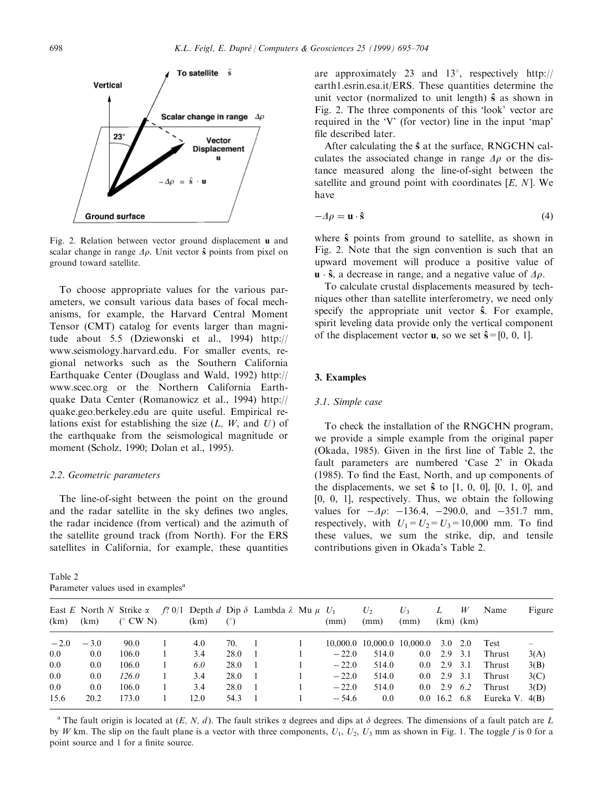

Figure . Relation between unit vector $\hat{s}$ and the ground displacement vector u. The unit vector points from the pixel on the ground toward the satellite. The three components (easting, northing, and upward) are specified in the file named gipht.in and read by GIPhT. Figure from Feigl and Dupre [Feigl and Dupré, 1999].

#### Fitting function

The file named **gipht.in** also includes the keyword **fitfun** that points to a Matlab function that calculates the modeled phase values from a set of parameters and metadata.

fitfun = funseparable25 % fitting function for elastic analytic models

The standard fitting function assumes that the temporal and spatial dependence can be separated, as shown mathematically in Figure 2.

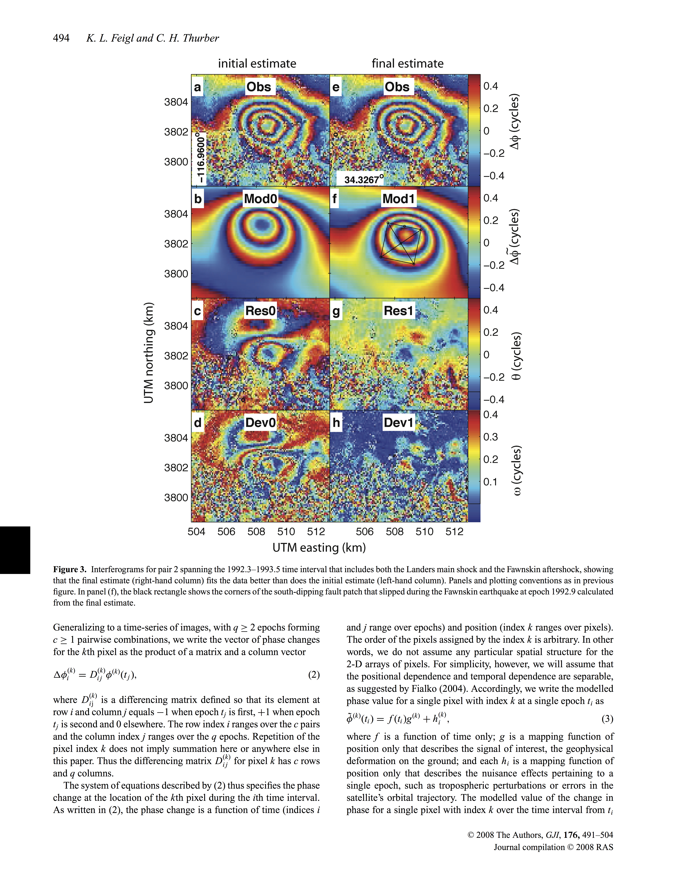



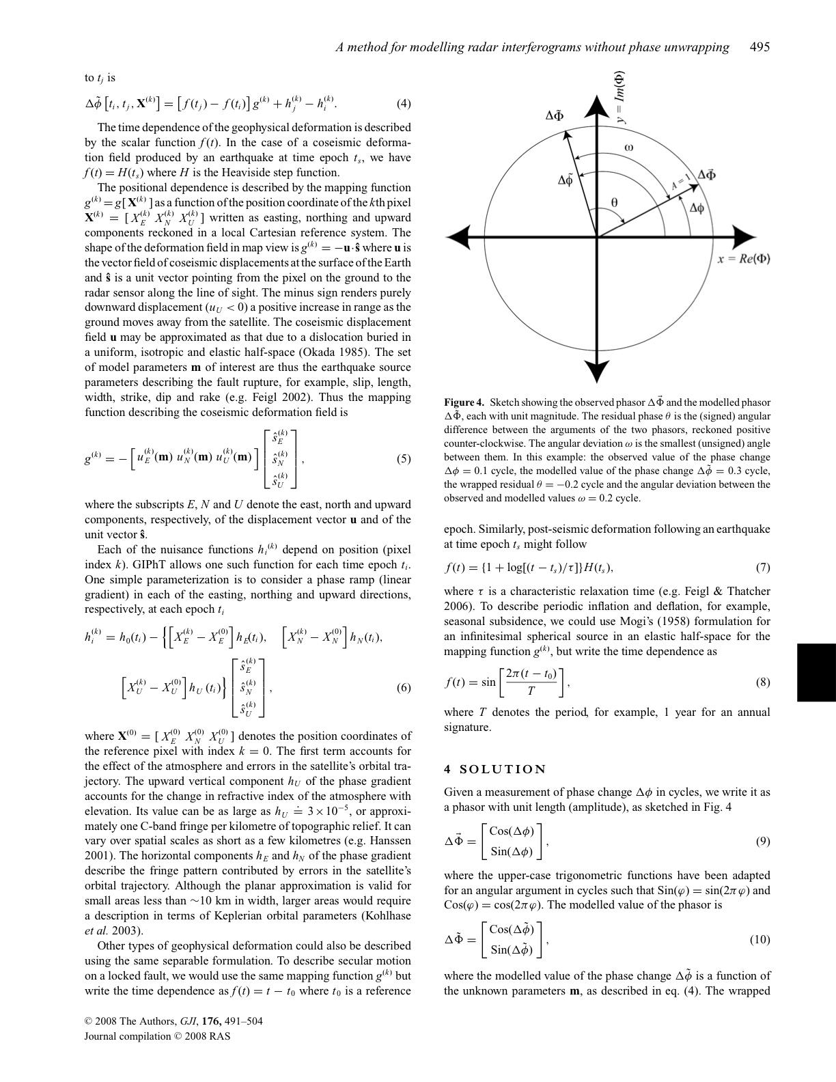



Figure . Definition of a separable fitting function, as described on pages 494–495 [*Feigl and Thurber*, 2009].

#### Parameter values

The file named **gipht.in** also includes the keyword **txtinname** that points to a file containing the initial estimate for each parameter. By convention, these files are named “.gin” for “GIPhT input”. An example of such a file appears in Figure 9.

%txtinname = demoF2.gin % 1 Okada source for Fawnksin for use with pselect set to 7

%txtinname = demoF3.gin % 1 Okada source for Fawnksin - no gradients

%txtinname = demoF4.gin % 1 Okada source for Fawnksin - includes gradients

%txtinname = demoF5.gin % same as above, but updated X,Y

%txtinname = demoF6.gin % same as above, but looser bounds for use with pselect 7

% used to make goodmodel psp_goodmodel_121x81.pha

%txtinname = demoF7.gin % same as above, but with all parameters fixed

%txtinname = demoF8.gin % same as above, but with moderately loose bounds

txtinname = demoF9.gin % same as above, but with X,Y bounded to +/- 500 m

%txtinname = mogiF1.gin % Mogi model for discrimination

#### Objective function

The file named **gipht.in** also includes the keyword **objfun** that points to a Matlab function that evaluates the objective (“cost”) function that is minimized by the inversion algorithm. The objective function measures the residual misfit between the observed and modeled values of phase.

objfun = funcostrarc % Objective Function mininum angle, assumes zero mean,

% using arc function in radians

By default, GIPhT calculates the objective function as the circular mean deviation $\overline{ω}$ of the residual phase values.



Figure . Sketch showing the angular deviation between the observed phase value and the modeled phase value in terms of the *arc* function, as described on page 496 [*Feigl and Thurber*, 2009].

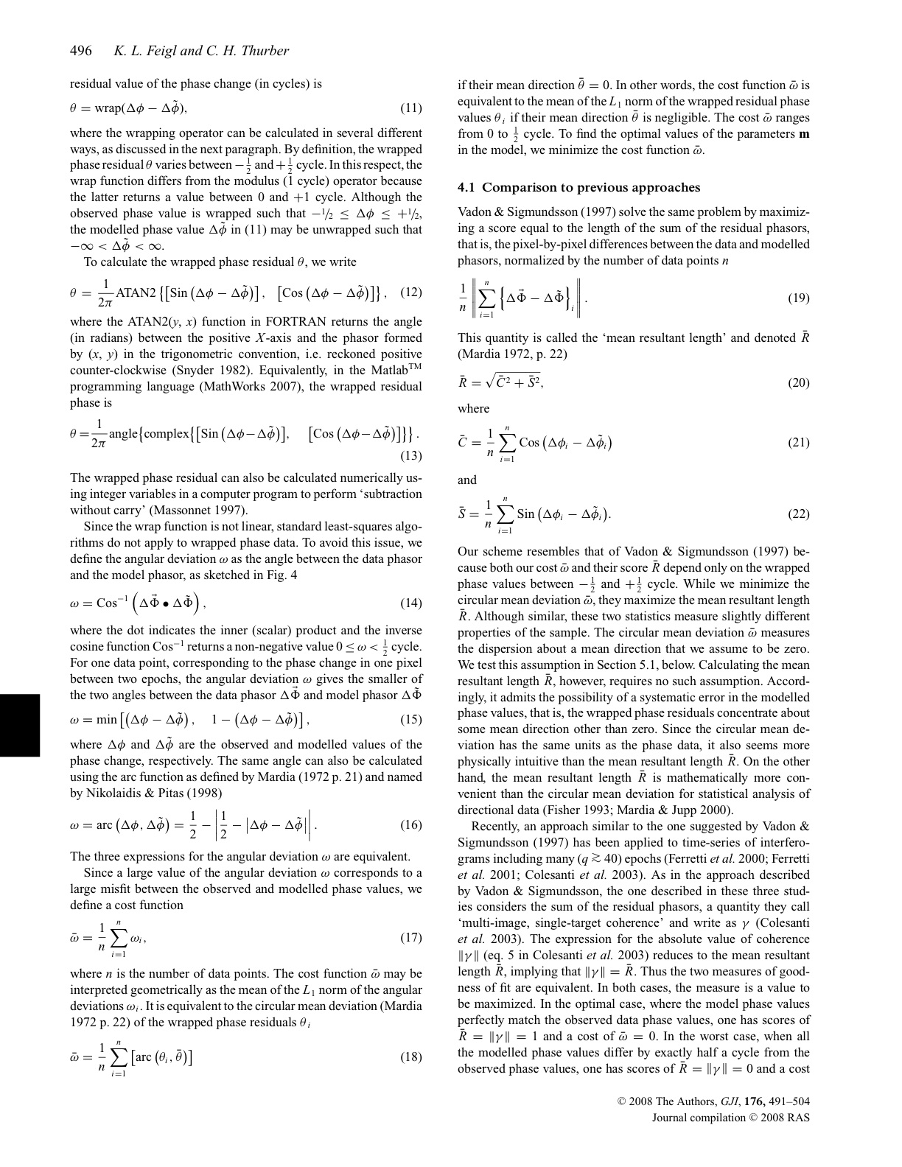

Figure . Definition of the cost function as the circular mean deviation $\overline{ω}$ of the residual (observed minus modeled) phase values, as described on page 496 [*Feigl and Thurber*, 2009]. The circular mean deviation $\overline{ω}$ is equivalent to the mean of the angular deviations, averaged over all pixels.



Figure . Mathematical definition of the angular deviation between the observed phase value and the modeled phase value in terms of the *arc* function, as described on page 496 [*Feigl and Thurber*, 2009]. If the angular deviation ω is zero, then the modeled phase value and the observed phase value agree perfectly. A small (ω < 0.1 cycle) value of the angular deviation (plotted in greenish colors) indicates the modeled phase value fits the observed phase value poorly. On the contrary, a large (ω > 0.3 cycle) angular deviation (plotted in reddish colors) indicates the modeled phase value fits the observed phase value poorly.

#### Algorithm for inversion

The file named **gipht.in** also includes the keyword **anneal** that controls how GIPhT performs the inversion. If keyword **anneal == 0**, then GIPhT simply copies the initial estimate of the parameters to the final estimate, without performing any inversion. This option is useful for forward modeling by trial and error, as described in the section on troubleshooting (VIII.B.1).

If keyword **anneal == 1**, then GIPhT uses simulated annealing, without recording all the trial values.

If keyword **anneal == 2**, then GIPhT uses simulated annealing, but (slowly) records all the trial values.

% CHOOSE ALGORITHM FOR INVERSION

anneal = 0 % 0 to skip Simulated Annealing

% anneal = 1 % 1 to run Simulated Annealing [DEFAULT]

% anneal = 2 % 2 to run S.A. with recording

#### Optional formats for graphics output

By default, the figures are recorded as Portable Document Format (PDF) files. These files have names ending in **.pdf.** They may be visualized directly using acrobat by clicking on them in the Windows Explorer. Specific examples are shown below. To change the format of the output graphics, other options include:

% How to record plots

%printfun = printnull % do not print plots to any files (fast)

%printfun = printps % print all plots to PostScript files (portable, but large)

%printfun = printpdf % print all plots to Portable Document Files files (compact)

printfun = printjpg % print all plots to JPEG image files

#### Options for graphic figures

By default, GIPhT plots figures in phase, rather than displacement. Other options include:

% How handle values for multi-panel plots

%figopt % xx1 propagate nulls from quadtree, paint missing data black

%figopt % x1x calculate modeled values at all pixel locations

%figopt % 1xx request grids and profiles of vector components of displacement

%figopt = 000 % none of the above

%figopt = 111 % do all of the above

%figopt = 110 % best-looking plots without black

figopt = 010 % good for short course

## Digital Elevation Model (DEM) — input descriptor file

The file named **dem_descriptor.dat** (and specified by the demdescfile keyword) is used to define the region covered by the interferograms recorded in the phase file(s). Each line contains a keyword followed by a numerical value or another keyword. The numerical values control how GIPhT reads the phase files. Note that the region must be the same in all the phase files. The various areal subsets are sketched in Figure 6. The file used for the example in the demo4 example appears in Figure 7.

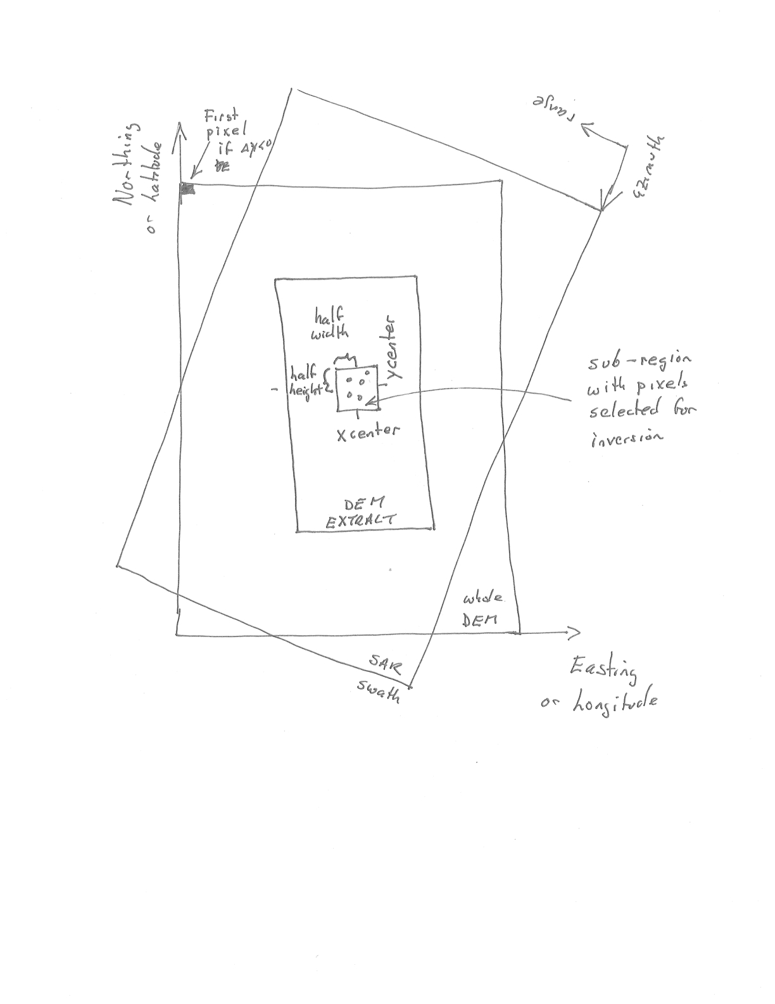

Figure . Sketch showing three subsets of the digital elevation model (DEM), namely: the entire area (largest rectangle), the extracted area (medium-sized rectangle), and the sub_region (smallest rectangle) used to select pixels for analysis with GIPhT. The phase files should cover exactly the same area as the extracted area. If no extraction is performed, then the extracted area covers the entire area of the DEM. In this case, the EXTRACTION keyword in the file named **dem_descriptor.dat** should be set to NON.

---------------------------------

FICHIER DESCRIPTIF D'UN MNT

DESCRIPTOR FILE OF THE DEM

---------------------------------

LANGUE franÁais

LNG fra

----------------------------------------------------------

FICHIER BINAIRE dem.i2

(BINARY FILE)

NOMBRE DE LIGNES 3000

(NUMBER OF ROWS) 3100

NOMBRE DE COLONNES 2400

(NUMBER OF COLUMNS)

(si fichier mnt effectif/if DEM file exists :)

CODAGE I2

(I2, I4 ou R4)

(si aucun fichier/if not :)

ALTITUDE CONSTANTE ---

(CONSTANT ELEVATION)

----------------------------------------------------------

EXTRACTION NON

(OUI ou NON)

(si oui :)

PREMIERE LIGNE EXTRAITE 1

(FIRST EXTRACTED ROW)

PREMIERE COLONNE EXTRAITE 241

(FIRST EXTRACTED COLUMN)

LIGNES EXTRAITES 1440

(EXTRACTED ROWS)

COLONNES EXTRAITES 1920

(EXTRACTED COLUMN)

PAS D'EXTRACTION DES LIGNES 1

(NO EXTRACTED ROW)

PAS D'EXTRACTION DES COLONNES 1

(NO EXTRACTED COLUMNS)

---------------------------------------------------------

OFFSET D'ALTITUDE 0.

(ELEVATION OFFSET)

FACTEUR D'ECHELLE ALTITUDE 1

(ELEVATION SCALE FACTOR)

ELLIPSOIDE ASSOCIE WGS84

(ASSOCIATED ELLIPSOID : NAD27, NTF, GRS80, ED50, WGS72 ou WGS84)

REFERENCE DES ALTITUDES GEOIDE

(ELEVATION REFERENCE : GEOIDE ou ELLIPSOIDE)

NATURE DES COORDONNEES GEOGRAPHIQUES

(SYSTEM OF COORDINATES : GEOGRAPHIQUES ou CARTOGRAPHIQUES)

---------------------------------------------------------

COORDONNEES GEOGRAPHIQUES

---------------------------------------------------------

(Si les coordonnees sont geographiques :)

(If it is a geographic system :)

LONGITUDE DU POINT 1 -118.0 (en degres)

(LONGITUDE POINT 1 in degrees)

PAS LONGITUDE 0.00083333333 (en degres)

(LONGITUDE GRID in degrees)

LATITUDE DU POINT 1 36.0 (en degres)

(LATITUDE POINT 1 in degrees)

PAS LATITUDE -0.00083333333 (en degres)

(LATITUDE GRID in degrees)

-----------------------------------------------------------

Figure Extract of the file named **dem_descriptor.dat** file used to define the region to be analyzed with GIPhT. This example describes a Digital Elevation Model (DEM) in geographic coordinates as latitude and longitude in decimal degrees.

## Digital Elevation Model (DEM) — input binary file

The binary file named **dem.i2** contains the digital elevation model (DEM). Topographic elevation is specified in meters as two (2) signed bytes per pixel, as described in the file named **dem_descriptor.dat**. The binary file named **dem.i2** is rectangular and flat. It contains no headers. Accordingly, the number of lines and columns should be identical to those of **all** the phase files. Since the DEM is coded as two bytes per pixel, the number of bytes in **dem.i2** should be exactly twice the number of bytes in each (and every) phase file if a subset of the DEM is defined (by setting the EXTRACTION keyword to NON in the file named **dem_descriptor.dat)**. The coordinates are implied. They may be specified in geographic (latitude and longitude in degrees) or cartographic (easting and northing in meters), as described in the file named **dem_descriptor.dat**.

## Input file file_names.dat

The file named **file_names.dat** defines the names of the phase files as well as the corresponding master epochs and slave epochs in decimal years. There is one line per interferometric pair. An example from **demo4** is shown in Figure 8. If **file_names.dat** is present, then **interferograms.lst** is ignored. GIPhT reads **file_names.dat** until the end or an incorrect format is found.

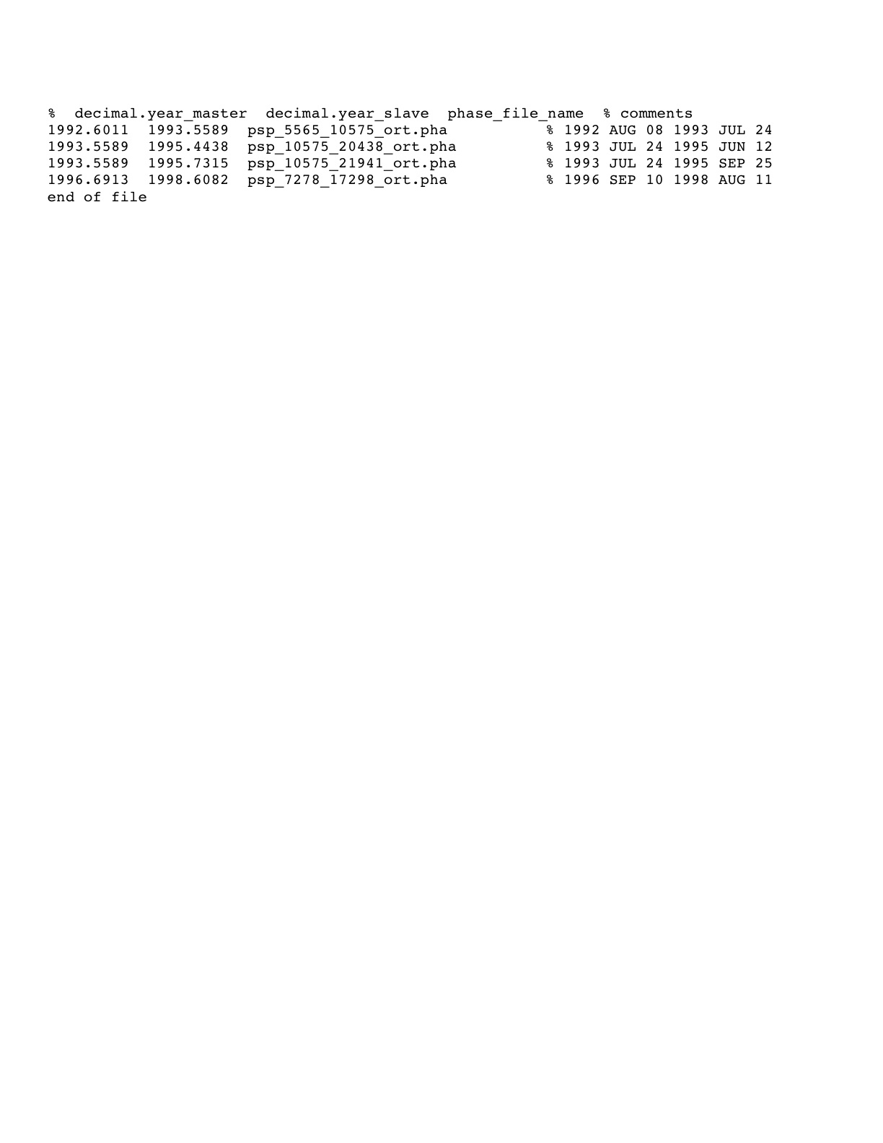

Figure . Example of file named **file_names.dat** used to define the master epochs, slave epochs, and phase files to be analyzed by GIPhT.

## Input file interferograms.lst (optional)

The file named **interferograms.lst** (and specified by the ilist keyword) contains the meta-data (e.g., dates and orbit numbers) of the interferometric pairs to analyzed. Interferometric pairs to be used should be flagged by including a lower-case letter 'a' at the end of the corresponding line. Note that the files are implied to have names of the form:

psp_10575_20438_ort.pha

where **10575** is the orbit number for the (older) master epoch and **20438** is the orbit number of the (younger) slave epoch. GIPhT reads **interferograms.lst** until the end or an incorrect format is found. This file also contains additional meta-data, e.g., calendar dates for the master and slave epochs, altitude of ambiguity, temporal separation, etc., for each interferometric pair. The file named **interferograms.lst** is ignored if **file_names.dat** is present.

## Input phase files

These binary files contain the InSAR phase change data for the region specified in dem_descriptor.dat. The phase values are coded as one (1) signed byte per pixel, such that

-128 DN = -0.5 cycle

0 DN = 0 cycle (or missing data)

+127 DN = + 0.5 cycle

256 DN = 1 cycle of wrapped phase

Filenames are built by parsing interferograms.lst or listed in **file_names.dat.** For example, the following four phase files are expected in **demo4:**

psp_10575_20438_ort.pha

psp_10575_21941_ort.pha

psp_5565_10575_ort.pha

psp_7278_17298_ort.pha

## Initial estimates of model parameters

The file named **demoF9.gin** (and specified by the txtiname keyword) contains the initial estimate and bounding values of the parameters. These values are used to calculate the modeled phase values. An example appears in Figure 9.

The simulated annealing algorithm in GIPhT tries many sets of values for the model parameters. It selects the set of parameter values that leads to the minimal value of the “cost function” as defined by Feigl and Thurber [*Feigl and Thurber*, 2009] in their equation (17). Adjusting the plusminus width of these bounds (the difference between the upper and lower bounding values) controls how GIPhT explores the parameter space. Widely spaced bounds leads to a more exhaustive search. An example for the fault depth parameter in the Fawnskin earthquake example appears in Figure 7 of Feigl and Thurber [*Feigl and Thurber*, 2009].

parameters.in for Fawnskin initial plusminus

Bperp___@_epoch_000_in_m_______ 0 0

E_grad__@_epoch_001_dimless____ -3.0e-06 0

E_grad__@_epoch_002_dimless____ 0. 0.0

E_grad__@_epoch_003_dimless____ 0. 0.0

N_grad__@_epoch_001_dimless____ -5.5e-06 0

N_grad__@_epoch_002_dimless____ 0 0

N_grad__@_epoch_003_dimless____ 0 0

U_grad__@_epoch_000_dimless____ 0 0

Okada1_Depth_in_m______________ 1.69e+03 1000

Okada1_Downdip_Slip_in_m_______ -5.63e-01 5.0e-2

Okada1_Easting_in_m____________ 507200 300

Okada1_Northing_in_m___________ 3802200 300

Okada1_Length_in_m_____________ 2.34e+03 500

Okada1_Negative_Dip_in_deg_____ -50.0 10

Okada1_RL_Strike_Slip_in_m_____ -1.99e-02 2.0e-2

Okada1_Strike_CCW_from_N_in_deg 282 15

Okada1_Tensile_Opening_in_m____ 0.0000 0

Okada1_Width_in_m______________ 2.78e+03 500

Poisson_Ratio_dimless__________ 0.25 0.

Shear_Modulus_in_Pa____________ 3.0E10 0.

Reference_Epoch_in_years_______ 1992.923497 0.

Figure Example of file named **demoF9.gin** used to define the initial values, lower bounds, and upper bounds of the model parameters to be estimated by GIPhT. If the value in the third column is zero, then upper bound equals the lower bound and the corresponding parameter is not adjusted. Three values must be present on each line. This file should not contain any tabs or blank lines.

## coh.byt

This file contains coherence values, coded as one (1) unsigned byte per pixel, such that 255 = perfect coherence. This optional file is not yet used.

# Output Files

GIPhT creates output of five different types, as described in detail below. All the output files produced by one run of GIPhT are placed in a directory named after the date and time of the run with a name of the form **x_YYYYMMDD_HHMMSS.** For example, **x_20090413_100015** denotes 15 seconds past 10:00 AM on 13 April 2009. Most of the output files also include a number indicating the interferometric pair, e.g., **x_001…, x_002…,** etc

### Log file

The log file, named **x.log,** records all pertinent information regarding the run.

### x.log

The file named **x.log** records all the intermediate steps taken by GIPhT. There is one such file per run.

### Output parameters file

The file named **x_parameters.out** contains the values of the parameters as estimated by GIPhT. There is one such file per run. An example appears in Figure 10. It also contains the statistical values used to evaluate its quality.

One line of this file pertains to one parameter, in the same format as the input parameters file. The values in the column labeled “initial” are those provided by the user as input before running GIPhT. The values in the column labeled “final” and highlighted in magenta are those estimated by GIPhT after running simulated annealing. The values in the column labeled “adjust” are the difference between the initial and final estimates of the model parameters. The values in the column labeled “sigma” are the uncertainties calculated by varying the parameters one parameter at a time, as described in section 5.2 of Feigl and Thurber [*Feigl and Thurber*, 2009]. One line indicates the “cost” (misfit) of the final estimate of the parameters. The “cost function” is defined by Feigl and Thurber [*Feigl and Thurber*, 2009] in their equation (17). ***This statistic is the best single number for assessing the quality of a solution.*** In particular, the cost of the final estimate should be lower than the cost of the initial estimate. If not, reconsider the bounding values, as described in the section below on troubleshooting (VIII.B.1)

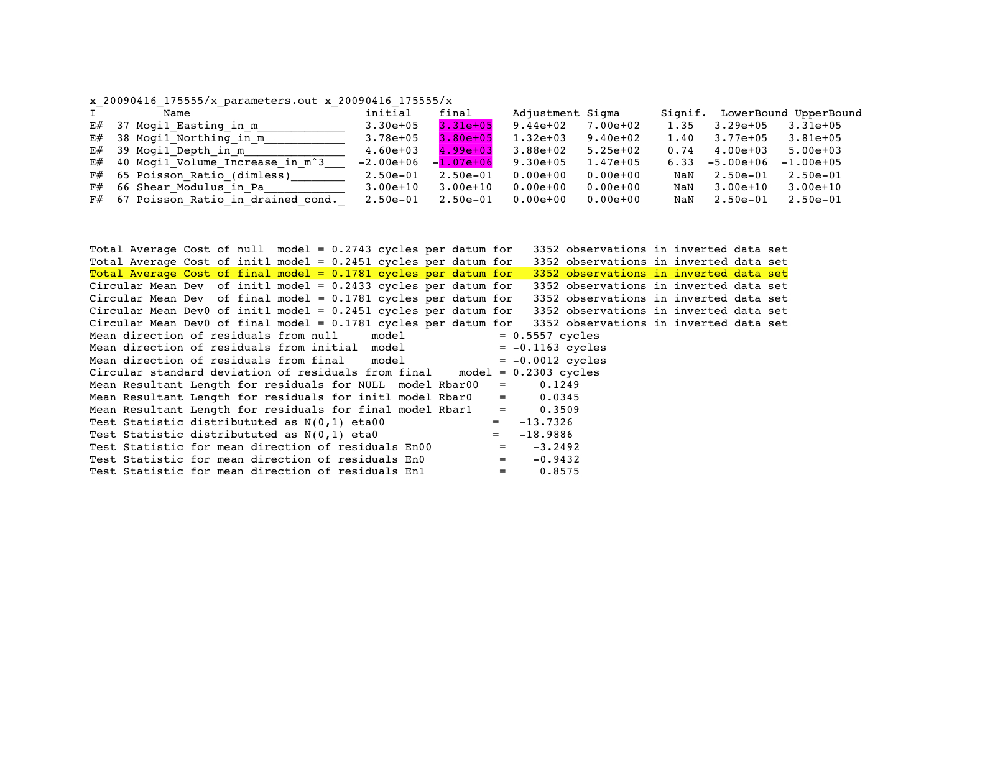

Figure Excerpts from file named **parameters.out** listing the model parameters estimated by GIPhT. The values in the column labeled “initial” are those provided by the user as input before running GIPhT. The values in the column labeled “final” and highlighted in magenta are those estimated by GIPhT after running simulated annealing. The values in the column labeled “adjust” are the difference between the initial and final estimates of the model parameters. The values in the column labeled “sigma” are the uncertainties calculated by varying the parameters one parameter at a time, as described in section 5.2 of [*Feigl and Thurber*, 2009]. The values in the column labeled “Signif” are the ratio of the adjustment to the uncertainty. The term “NaN” denotes “not a number”, or an undefined value, e.g., the result of dividing by zero. The line highlighted in yellow indicates the cost of the final estimate of the parameters. This statistic is the best single number for assessing the quality of a solution.

#### 8-panel plot named x_001_8PAN.pdf

This 8-panel plot that summarizes the results from GIPhT succintly. There is one such file for each pair. For the Iceland example in the demo4 directory, the 8-panel plot appears in **Error! Reference source not found.**. For the Fawnskin earthquake example, these plots appear as Figures 2 and 3 of Feigl and Thurber [*Feigl and Thurber*, 2009]. The panels in the left column include:

(a) observed phase values;

(b) modeled phase values calculated from the initial estimate;

(c) initial residual phase values formed by subtracting the initial modeled phase values from the observed phase values;

(d) angular deviations for the initial estimate;

The panels in the right column include:

(e) observed phase values, repeated for convenience;

(f) modeled phase values calculated from the final estimate;

(g) final residual phase values formed by subtracting the final modeled values from the observed phase values;

(h) angular deviations for the final estimate.

In the upper three rows, one colored fringe corresponds to one cycle of phase change, or 28 mm of range change. In the lowermost (fourth) row, the colors denote the angular deviation in phase between 0 and ½ cycle. Coordinates are Universal Transverse Mercator easting and northing in km outside the frames.

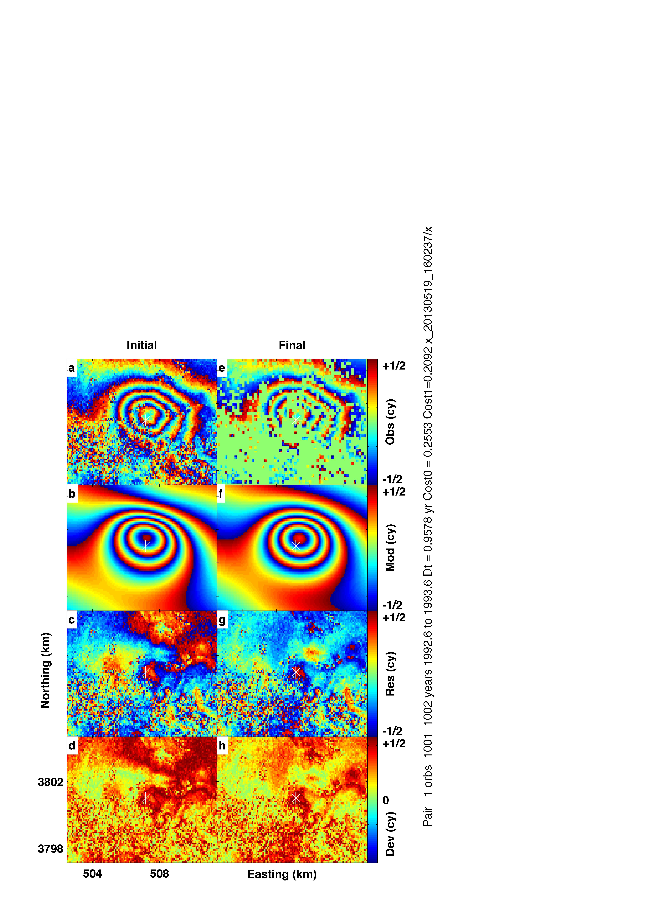

aa

Figure . An example of an 8-panel plot for pair 2 of **demo4**. The left panel pertains to the initial estimate of the model parameters, before GIPhT attempts to optimize the fit of model to data. The panels in the **left** **column** include, from top to bottom: (a) observed phase values; (b) modeled phase values calculated from the initial estimate; (c) initial residual phase values formed by subtracting the initial modeled phase values from the observed phase values; (d) angular deviations for the initial estimate. The **right column** pertains to the final estimate of the model parameters, as determined by the simulated annealing algorithm within GIPhT. The panels in the right column include: (e) observed phase values, repeated for convenience; (f) modeled phase values calculated from the final estimate; (g) final residual phase values formed by subtracting the final modeled values from the observed phase values; (h) angular deviations for the final estimate. In the **upper three rows**, one colored fringe corresponds to one cycle of phase change, or 28 mm of range change. In the **lowermost (fourth) row**, the colors denote the angular deviation in phase between 0 and ½ cycle. Coordinates are Universal Transverse Mercator easting and northing in km outside the frames. Metadata describing the interferometric pair are written along the right edge of the page.

### Phase values plotted on maps with coordinates

These maps are recorded in the files using the format specified by the printfun keyword. By default, the figures are in Portable Document Format (PDF) files. These files have names ending in **.pdf**. They may be visualized directly by clicking on them directly in the Finder window. There is one such file for each pair.

#### x_001_OBS1.pdf

Map of observed phase values. Circles denote pixels selected for the inversion.

#### x_001_MOD1.pdf

Map of modeled phase values calculated using the final estimates of the model parameters.

#### x_001_RES1.pdf

Wrapped residual phase calculated by subtracting the modeled phase values from the observed phase values and wrapping the difference (modulo 1 cycle). This figure should show a small number of fringes.

#### x_001_DEV.pdf

Values of the angular deviation (also called “cost”), ranging from a minimum of 0.0 cycles, shown as blue, (modeled and observed phase values agree perfectly) to a maximum of 0.5 cycles, shown as red, (modeled and observed phase values disagree extremely badly). In other words a model that fits the observations well will show more blue pixels than red.

### Phase values in binary RAW format

These binary files have names ending in **.pha**. They cannot be visualized directly.

### Phase files

All the files with names ending in **.pha** contain phase data coded as described above. The following output phase files are 2-dimensional arrays covering the selected sub-region. In general, the output phase files are smaller than the input phase files. For each interferometric pair, there are four output files.

#### x_001_OBSV.pha

Observed wrapped phase values as read by GIPhT. The values range from ‑0.5 to +0.5 cycles.

#### x_001_MODL.pha

Modeled wrapped phase values calculated from the final estimate of the modeled phase parameters. The values range from ‑0.5 to +0.5 cycles.

#### x_001_RESD.pha

Wrapped residual phase calculated by subtracting the modeled phase values from the observed phase values and wrapping the difference (modulo 1 cycle). The values range from ‑0.5 to +0.5 cycles.

#### x_001_COST.pha

Values of the angular deviation (also called “cost”), ranging from 0.0 cycles (modeled and observed phase values agree perfectly) to 0.5 cycles (modeled and observed phase values disagree completely).

### ikeep.mat and jkeep.mat

The binary files named **ikeep.mat** and **jkeep.mat** contain the indices to the pixels selected by GIPhT for analysis. To re-use the same pixels in subsequent inversions, set the **pselect** keyword to 2 in the file called **gipht.in**. To randomly select a new set of pixels in subsequent inversions, set the **pselect** keyword to 1 in the file called **gipht.in**. In this case, the binary files named **ikeep.mat** and **jkeep.mat** will be ignored.

### matlab.mat

Used by GIPhT to pass data from one processing step to another. For the demonstration, this file should be deleted to avoid filling the hard disk space.

### unitv.mat

Used by GIPhT to pass data from one processing step to another. For the demonstration, this file should be deleted to avoid filling the hard disk space.

### unitv2.mat

Used by GIPhT to pass data from one processing step to another. For the demonstration, this file should be deleted to avoid filling the hard disk space.

### x.pdf

Splash screen showing version number of GIPhT and legal messages.

# Subsidence Example (demo4)

## Description

This example shows subsidence in Iceland, using four interferometric pairs. The subsidence signal is caused by the withdrawal of fluids at the Svartsengi geothermal field, near the Blue Lagoon on the Reykanes Peninsula (Figure 12).

A map is shown in Figure 13 .The geothermal resourced has been described by Bjornsson [*Björnsson*, 1999]. A copy of this paper is provided in the file called **doc/Bjornsson.pdf**.

The subsidence was observed by InSAR [*Vadon and Sigmundsson*, 1997]. A copy of this paper is provided in the file called **doc/VadonAndSigmundsson1997Science.pdf**.

The model for the subsidence is an infinitesimal sphere that decreases its volume at constant rate, also called a “point sink”. This sphere is embedded in an elastic half-space with a known Poisson’s ratio. This model was developed by Mogi [*Mogi*, 1958]. It includes four free parameters: easting coordinate, northing coordinate, depth, and volume change (rate) as sketched in Figure 13.

***In this example, the volume change is assumed to vary linearly with the time spanned by the interferograms. In other words, the rate of volume change rate is assumed to be constant. In theory, the Poisson’s ratio can also be adjusted.*** In practice, however, it tends to trade off with the depth parameter.

Although the Mogi model fits the InSAR data in this example, it leads to an estimate of the depth that is deeper than that inferred from other geophysical data. One possible explanation may be that some of the assumptions in the Mogi model are inappropriate. These issues have been explored by Akarvardar et al. [*Akarvardar et al.*, 2007]. This paper also applies a Mogi model to a subsidence signal recorded by InSAR. A copy of the corrected proofs of this paper is provided in the file called

**doc/gji_4126_corrections20090403.pdf.**

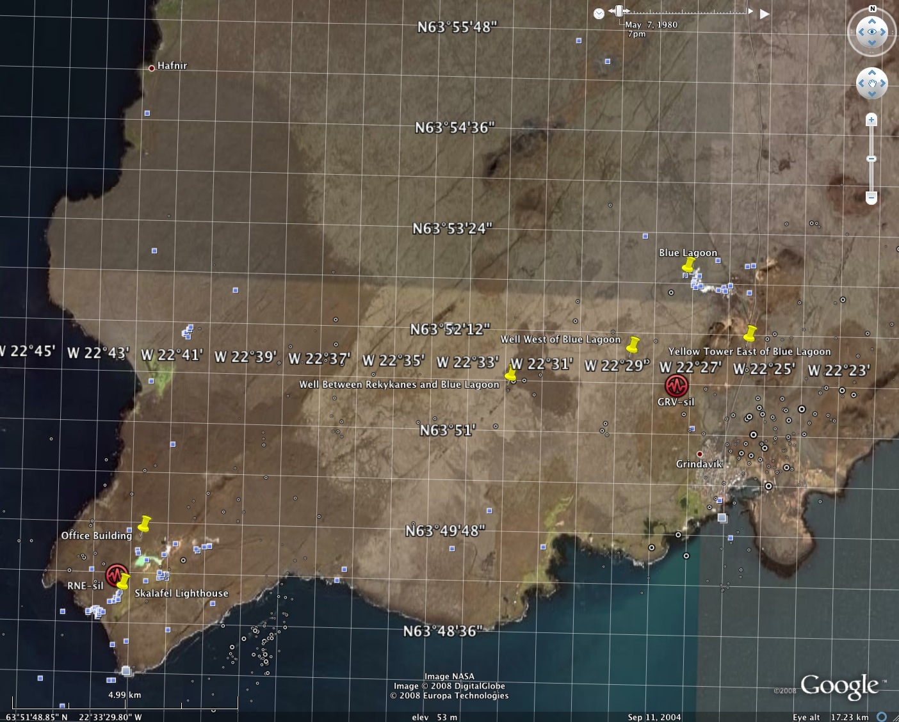

Figure . Optical image of the Reykanes Peninsula in southwest Iceland showing the study area for demonstration data set **demo4** for monitoring subsidence produced by withdrawal of geothermal fluids near the Blue Lagoon. Figure from Google Earth.

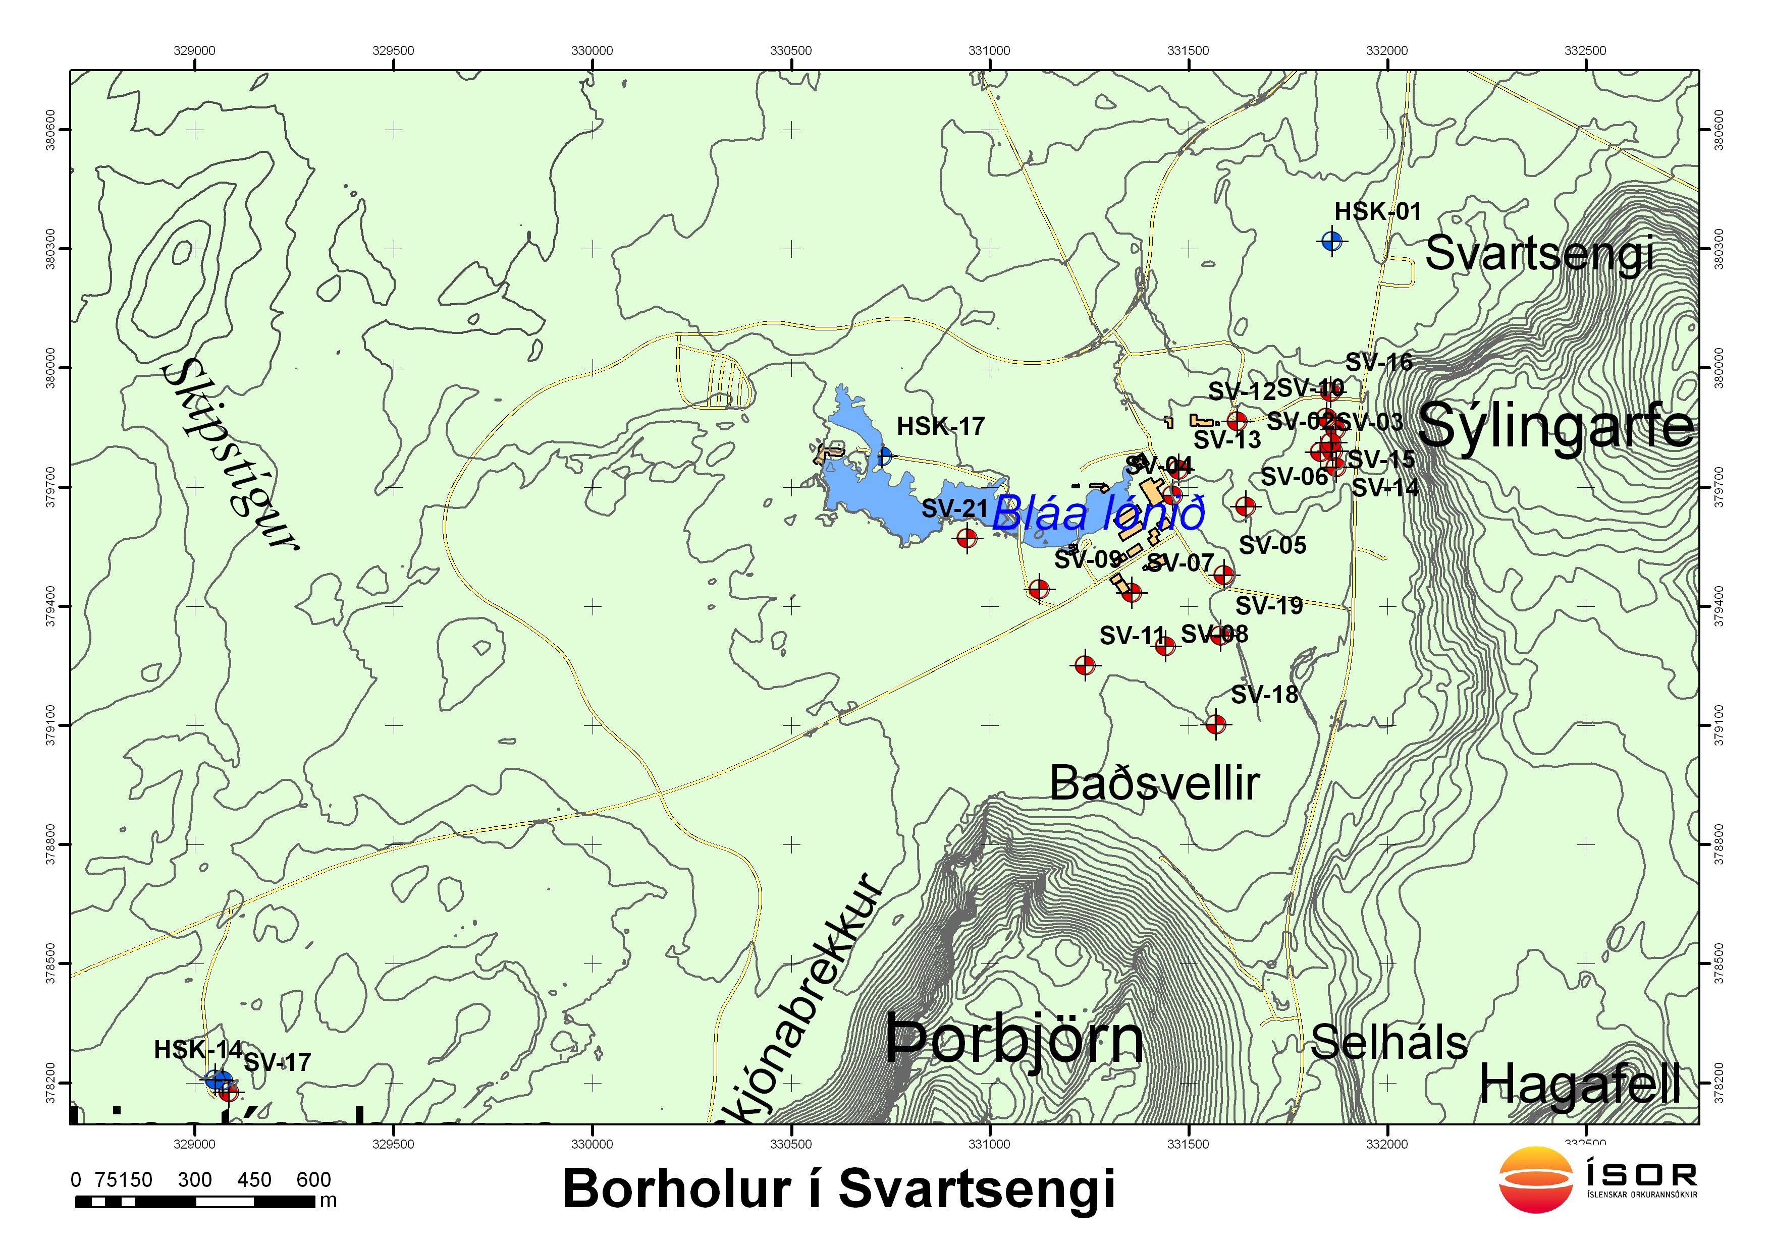

Figure . Map of the geothermal fields near the Blue Lagoon. Figure courtesy of ISOR.

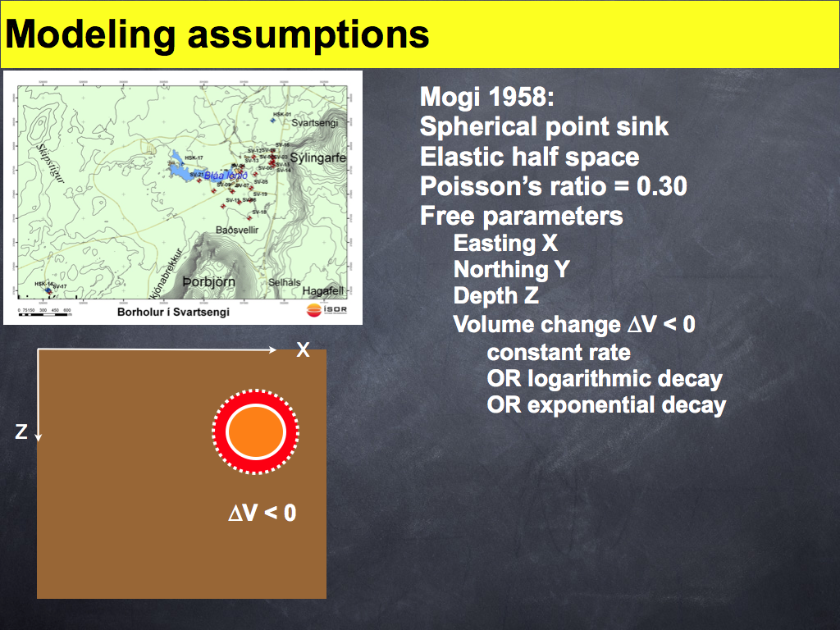

Figure . Cartoon of a Mogi model showing the parameters of 3-dimensional position (X = easting, Y = northing, out of page, Z, depth) and volume change *ΔV* (red shell). The spherical source changes its volume from the dashed line to the solid line.

# Applying GIPhT to other Data Sets

## Make and populate a directory

GIPhT operates in a directory (folder) that is later named in on the command line. For example, to consider a data set called **my_data**, make a directory by typing:

mkdir my_data

It should be at the same hierarchical level as the other demonstration directories, so that when you type **ls**, you see:

demo2

demo4

demoF

my_data

You will need all the input files with the names and contents that are described in Section IV above. We suggest copying them from **demo2** and then modifying them with a text editor such as **TextEdit.app**.

### reduce the number of pairs

Decrease the number of phase files listed in **files_list.dat** or **interferograms.lst.** For example, the data set included in the directory named **demo2** is the fastest example because it includes only a single pair.

# Troubleshooting

## Calculation takes too long

The simulated annealing algorithm employed in GIPhT evaluates many (~104) possible sets of values for the model parameters by calculating the modeled range change value for every pixel in every interferometric pair. To improve performance by reducing the calculating time, try one of the following:

### Reduce the number of pairs

Decrease the number of phase files listed in **files_list.dat** or **interferograms.lst.** For example, the data set included in the directory named **demo2** is the fastest example because it includes only a single pair. To start the quickest demonstration, type:

gipht

### Reduce the number of pixels

Decrease the numerical value following the **npix** keyword in **gipht.in.**

### Avoid quadtree sampling of the data set

Set the **pselect** keyword in **gipht.in** to 1 or 2 (not 3).

## Final estimate does not look like the data

The goal of using GIPhT is to make a modeled interferogram that resembles the observed interferogram. In the second column of the 8-panel plot, the model (second row, panel f) should have fringes that look like the observations (first row, panel e). In this case, the residual (third row, panel g) should show less than one fringe. Equivalently, the angular deviations (fourth row, panel h) should be less than 0.1 or 0.2 cycle over most of the sub-region. In other words, most pixels in the final panel of an 8-panel plot should be blue, rather than red in color. If this is not the case, consider the following:

### Improve the initial estimate

Trial and error using human intuition can be more efficient than simulated annealing, especially when starting with a new data set. To modify the parameter values manually, set the anneal keyword to 0 in the file named **gipht.in.** This will turn “off” simulated annealing. Then “play” with the parameters defined in the second column of the file named **parameters.in.** Then look at the output residuals and angular deviations. When you are satisfied, adjust the upper and lower bounds to be “close to” (within 10 or 20%) these values in the file named **parameters.in.** Then set the **anneal** keyword back to 1 in the file named **gipht.in.**

### Check the sign of the phase values

As an observer’s eye scans a path across an interferogram, phase can either increase (colors going from blue to green to yellow to red) or decrease (colors going from red to yellow to green to blue). The fringe gradient should have the same sense in both the observed and modeled interferograms. If not, consider changing the sign of the **volume_change** (rate) parameter in **parameters.in.** Alternatively, there may issues with the file format. In this case, consider multiplying all the phase values in the input phase files by negative one to change their sign. GIPhT assumes that positive phase values correspond to increases in range.

### Shrink the sub-region

The information in an interferogram is contained in the gradient of the phase values. Accordingly, it is best to analyze pixels where this gradient is large. To do so, set the values of **xcenter** and **ycenter** to the coordinates of the center of the fringe pattern of interest, and decrease the values of the keywords **half_width** and **half_height** in the file named **sub_region.dat**.

## The residual interferogram shows twice as many fringes as either the observed or the modeled interferogram.

The phase gradient in the modeled interferogram is opposite that in the observed interferogram. Check the sign of the phase values, as described above.

## The model is all green.

If the modeled phase values are all zero, then they will appear as a uniform green field in panel f of an 8-panel plot. Usually this issue is caused by a mismatch of coordinates of the source defined in the **parameters.in** file compared to the image coordinates specified in the file named **dem_descriptor.dat.** We find it helpful to sketch the different subsets of the study area as in Figure 6.

## There are crenulated fringes in some of the interferograms.

Tropospheric artefacts are challenging to model. If they occur only in a small subset of the interferometric pairs, then we recommend removing these pairs from the analysis. Alternatively, GIPhT can estimate the vertical component of the phase gradient. To do so, use the parameter labeled **vertical_gradient** in the file named **parameters.in**. Estimate this parameter only for those epochs that form the pair(s) showing the crenulated interferometric fringes in the observed interferogram(s). Given enough pairs, one can usually determine if the tropospheric perturbation occurred at the master epoch or the slave epoch, using pair-wise discrimination, as described by Massonnet and Feigl [*Massonnet and Feigl*, 1995; *Massonnet and Feigl*, 1998].

## I do not have a DEM.

To make a flat digital elevation model with a topographic height of zero everywhere, try the following command in unix.

dd if=/dev/zero of=dem.i2 \

bs=1600 count=420

where 1600 is twice the number of columns and 420 is the number of rows. In this case, however, GIPhT will not be able to estimate the vertical component of the phase gradient.

## The format of the parameters.in file is wrong

If GIPhT generates error messages when reading the values of the parameters in the file named **parameters.in**, you can generate a new file with the proper format, but null values by following the following steps:

Rename or delete the existing file

mv parameters.in params0.in

Run GIPhT on your data again:

giphtdemo my_data

Copy the output file

cp x_*/x.log parameters.in

Using the **TextEdit.app** program, edit the file named **parameters.in** so that it has only one header line, as shown in parameters.in for Fawnskin initial plusminus

Bperp___@_epoch_000_in_m_______ 0 0

E_grad__@_epoch_001_dimless____ -3.0e-06 0

E_grad__@_epoch_002_dimless____ 0. 0.0

E_grad__@_epoch_003_dimless____ 0. 0.0

N_grad__@_epoch_001_dimless____ -5.5e-06 0

N_grad__@_epoch_002_dimless____ 0 0

N_grad__@_epoch_003_dimless____ 0 0

U_grad__@_epoch_000_dimless____ 0 0

Okada1_Depth_in_m______________ 1.69e+03 1000

Okada1_Downdip_Slip_in_m_______ -5.63e-01 5.0e-2

Okada1_Easting_in_m____________ 507200 300

Okada1_Northing_in_m___________ 3802200 300

Okada1_Length_in_m_____________ 2.34e+03 500

Okada1_Negative_Dip_in_deg_____ -50.0 10

Okada1_RL_Strike_Slip_in_m_____ -1.99e-02 2.0e-2

Okada1_Strike_CCW_from_N_in_deg 282 15

Okada1_Tensile_Opening_in_m____ 0.0000 0

Okada1_Width_in_m______________ 2.78e+03 500

Poisson_Ratio_dimless__________ 0.25 0.

Shear_Modulus_in_Pa____________ 3.0E10 0.

Reference_Epoch_in_years_______ 1992.923497 0.

Figure 9. Edit the values for the initial estimate, as well as the lower and upper bounds for each parameter.

Run GIPhT on your data again:

giphtdemo my_data

## The program crashes

### Remain calm

Remember, this version of GIPhT is still under development. With your constructive criticism, the software can be improved.

### Look for hints in the output

Please check the following issues:

Are all the phase files available for reading? Missing files will leave an error message.

Are the input files properly formatted? A letter in place of a number will cause a problem.

Are the parameter values in the initial estimate and bounds physically reasonable? The following are examples of unreasonable values: negative values for depth, source dimensions larger than Earth or smaller than a pixel, or a negative value for the upward component of the look vector from ground to satellite.

### Send the output to Madison

If you wish to report an issue, please send an email to [feigl@wisc.edu](mailto:feigl@wisc.edu) with the word “GIPhT” in the subject field. Be sure to include the following:

The output left from the terminal window. Please copy the last 100 lines and paste it into the email text. Alternatively, you can capture the screen with **Grab.app** or the keystroke combination CMD-SHIFT-3 which creates a file called **Picture001.png** file on the desktop.

The most recent log file, called **x.log**. In the event of a crash, it will not be moved to the corresponding directory.

# Conclusion

To be written by you, the user. Thanks for your interest!

References

Akarvardar, S., K. L. Feigl, and S. Ergintav (2007), Subsidence in the Avcilar district of Istanbul, Turkey measured by satellite radar interferometry 1992 - 1999, *Geophys J Int, in press*.

Ali, S. T., and K. L. Feigl (2012), A new strategy for estimating geophysical parameters from InSAR data: application to the Kraﬂa central volcano, Iceland, *Geochemistry, Geophysics, Geosystems, 13*. <http://dx.doi.org/10.1029/2012GC004112> We develop, validate, and apply a new strategy for estimating parameters in a geophysical model from interferometric synthetic aperture radar (InSAR) measurements. The observable quantity is a particular component of the deformation gradient tensor, deﬁned as the derivative of the change in range with respect to the easting coordinate. This range change gradient is derived from wrapped phase data by a quadtree resampling procedure. Since the range change gradient is a continuous function, the strategy avoids the pitfalls associated with phase unwrapping techniques. To quantify the misﬁt between the observed and modeled values of the range gradient, the objective function calculates the cost as the absolute value of their diﬀerence, averaged over all samples. To minimize the objective function, we use a simulated annealing algorithm. This algorithm requires several thousand evaluations of the ﬁtting function to ﬁnd the optimum solution: the estimate of the model parameters that produces the lowest value of cost. For computational effciency, we approximate the ﬁtting function using Taylor series. The simulated annealing algorithm then evaluates the approximate and fast version of the ﬁtting function. After performing these two steps several times, the scheme converges, typically in a few iterations. We apply the strategy to Kraﬂa central volcano in Iceland. Using a data set composed of eight interferometric pairs acquired by the ERS-1 and ERS-2 satellites over a 6-year interval between 1993 and 1999, we estimate the four parameters in a Mogi model. Results suggest a source at 4.98 ± 0.21 km depth and a deﬂation rate that decays exponentially over the interval, in agreement with prior studies.

Björnsson, G. (1999), Predicting future performance of a shallow steam zone in the Svartsengi geothermal field, Iceland, paper presented at Proceedings of the Twenty-Fourth Workshop on Geothermal Reservoir Engineering, Stanford University, Stanford, California, January 25-27, 1999, SGP-TR-162.

Feigl, K. L., A. Sergent, and D. Jacq (1995), Estimation of an earthquake focal mechanism from a satellite radar interferogram: application to the December 4, 1992 Landers aftershock, *Geophys. Res. Lett., 22*, 1037-1048. Using the interferometric fringes generated by the phase difference between a pair of synthetic-aperture radar (SAR) images acquired by the ERS-1 satellite, we estimate the focal mechanism of a small, shallow thrust earthquake. The inversion procedure is an iterative, linearized least-squares algorithm based on a standard elastic dislocation formulation for coseismic displacements. Our preferred estimate is a thrust focal mechanism with its hypocenter at (N34.35 ± 0.4 km, W116.91 ± 0.2 km, 2.6 ± 0.3 km depth) on a plane dipping southward beneath the San Bernardino Mountains, with a moment magnitude (Mw) of 5.4. The strike, dip, and rake are N106E ± 7, 28 ± 4, and 93 ± 4, respectively on a fault 3.1 ± 0.5 km wide and 2.9 ± 0.4 km long. The precision of these estimates is competitive with seismological determinations.

Feigl, K. L., and E. Dupré (1999), RNGCHN: a program to calculate displacement components from dislocations in an elastic half-space with applications for modeling geodetic measurements of crustal deformation, *Computers and Geosciences, 25*, 695-704. The RNGCHN program calculates a single component of the displacement field due to a finite or point-source dislocation buried in an elastic half space. This formulation approximates the surface movements produced by earthquake faulting or volcanic intrusion. As such, it is appropriate for modeling crustal deformation measured by geodetic surveying techniques, such as spirit leveling, trilateration, Very Long Baseline Interferometry (VLBI), Global Positioning System (GPS), or especially interferometric analysis of synthetic aperture radar (SAR) images. Examples suggest that this model can fit simple coseismic earthquake signatures to within their measurement uncertainties. The program's input parameters include fault position, depth, length, width, strike, dip, and three components of slip. The output consists of displacement components in the form of an ASCII list or a rectangular array of binary integers. The same program also provides partial derivatives of the displacement component with respect to all 10 input parameters. The FORTRAN source code for the program is in the public domain and available as the compressed tar file rngchn.tar.Z in the directory /pub/GRGS via the Internet by anonymous ftp to spike.cst.cnes.fr. This distribution includes worked examples and a MATLAB interface.

Feigl, K. L., and C. H. Thurber (2009), A method for modelling radar interferograms without phase unwrapping: application to the M 5 Fawnskin, California earthquake of 1992 December 4, *Geophys. J. Int., 176*, 491-504. <http://dx.doi.org/10.1111/j.1365-246X.2008.03881.x> Interferometric analysis of synthetic aperture radar images (InSAR) measures the phase shifts between two images acquired at two distinct times. These ambiguous 'wrapped' phase values range from -1/2 to +1/2 cycles. The standard approach interprets the phase values in terms of the change in distance between the ground and the radar instrument by resolving the integer ambiguities in a process known as 'unwrapping'. To avoid unwrapping, we have developed, validated and applied a new method for modelling the wrapped phase data directly. The method defines a cost function in terms of wrapped phase to measure the misfit between the observed and modelled values of phase. By minimizing the cost function with a simulated annealing algorithm, the method estimates parameters in a non-linear model. Since the wrapped phase residuals are compatible with a von Mises distribution, several parametric statistical tests can be used to evaluate the fit of the model to the data. The method, named General Inversion for Phase Technique (GIPhT), can handle noisy, wrapped phase data. Applying GIPhT to two interferograms in the area of Fawnskin, California, we estimate a set of model parameters describing a magnitude 5 aftershock of the 1992 Landers earthquake. The resulting simulation fits the data well. The phase final residuals have a circular mean deviation less than 0.15 cycles per datum. Sampling the final residuals, we find the circular standard deviation of a phase measurement to be approximately 0.2 cycle, corresponding to 6 mm in range.

Massonnet, D., and K. L. Feigl (1995), Discriminating geophysical phenomena in satellite radar interferograms, *Geophys. Res. Lett., 22*, 1537-1540. Various geophysical phenomena are recorded in the interference patterns formed by differencing two synthetic aperture radar (SAR) images. The fringes generated by the topographic relief can be removed using a digital elevation model (DEM). The remaining fringes map the change in satellite-to-ground range which occurred between the acquisition times of the two images. By comparing different pairs of images spanning different intervals of time, it is possible to discriminate between geophysical signal and interferometric artifact. Here we apply this pair-wise logic to the area around the 1992 Landers, California earthquake using SAR images acquired by the ERS-1 satellite. The range varies with time as a constant, step, impulsive, or sloping function. Examples of each type include a DEM error, an aftershock, two atmospheric perturbations, and postseismic afterslip, respectively. Their signatures are identified and separated using the pair-wise logic.

Massonnet, D., and K. L. Feigl (1998), Radar interferometry and its application to changes in the Earth's surface, *Rev. Geophys., 36*, 441-500. <http://www.agu.org/journals/rg/rg9804/97RG03139/97RG03139.pdf> Geophysical applications of radar interferometry to measure changes in the Earth's surface have exploded in the early 1990s. This new geodetic technique calculates the interference pattern caused by the difference in phase between two images acquired by a spaceborne synthetic aperture radar at two distinct times. The resulting interferogram is a contour map of the change in distance between the ground and the radar instrument. These maps provide an unsurpassed spatial sampling density (~100 pixels/km2), a competitive precision (~1 cm) and a useful observation cadence (1 pass/month). They record movements in the crust, perturbations in the atmosphere, dielectric modifications in the soil, and relief in the topography. They are also sensitive to technical effects, such as relative variations in the radar's trajectories or variations in its frequency standard. We describe how all these phenomena contribute to an interferogram. Then a practical summary explains the techniques for calculating and manipulating interferograms from various radar instruments, including the four satellites currently in orbit: ERS-1, ERS-2, JERS-1 and RADARSAT. The next chapter suggests some guidelines for intepreting an inteferogram as a geophysical measurement: respecting the limits of the technique, assessing its uncertainty, recognizing artifacts and discriminating different types of signal. We then review the geophysical applications published to date, most of which study deformation related to earthquakes, volcanos and glaciers using ERS-1 data. We also show examples of monitoring natural hazards and environmental alterations related to landslides, subsidence, and agriculture. In addition, we consider subtler geophysical signals such as postseismic relaxation, tidal loading of coastal areas, and interseismic strain accumulation. We conclude with our perspectives on the future of radar interferometry. The objective of the review is for the reader to develop the physical understanding necessary to calculate an interferogram and the geophysical intuition necessary to interpret it.

Mogi, K. (1958), Relations between the eruption of various volcanoes and the deformations of the ground surfaces around them, *Bull. Earthquake Research Institute, 36*, 99-134.

Vadon, H., and F. Sigmundsson (1997), 1992-1995 Crustal deformation at Mid-Atlantic ridge, SW Iceland, mapped by radar interferometry, *Science, 275*, 194-197. Satellite radar interferometry observations of the Reykjanes Peninsula oblique rift in southwest Iceland show that the Reykjanes central volcano subsided at an average rate of up to 13 millimeters per year from 1992 to 1995 in response to use of its geothermal field. Interferograms spanning up to 3.12 years also include signatures of plate spreading and indicate that the plate boundary is locked at a depth of about 5 kilometers. Below that depth, the plate movements are accommodated by continuous ductile deformation, which is not fully balanced by inflow of magma from depth, causing subsidence of the plate boundary of about 6.5 millimeters per year.